Phang Teng Fone 1003296

Hw11

1) Critic

|  |
| --- |
| # Critic class Critic(nn.Module):    def __init__(self, image_size):  """  Only forced parameter will be the image size, set to 28.  n = batch size,c = channel,h = height,w = width  """  super().__init__()   # Encoder part will be a simple sequence of Conv2d+ReLU.  self.D = nn.Sequential(nn.Conv2d(1,16, 6, stride = 3, padding = 0),  nn.LeakyReLU(0.2),  nn.Conv2d(16, 32, 4, stride = 3, padding = 1),  nn.LeakyReLU(0.2),  nn.Conv2d(32, 1, 4,stride = 2, padding = 1)  )    def forward(self, x):  x = self.D(x)  return x |

2) Generator

|  |
| --- |
| # Generator  class Generator(nn.Module):    def __init__(self, latent_size, image_size):  """  Only forced parameters will be the image size, set to 28,  and the latent size set to 64.   output should be = batchsize, 1 , 28,28  input dimension(32,64,1,1)  """  super().__init__()  self.G = nn.Sequential(nn.ConvTranspose2d(latent_size, 32, 7 , stride = 1),  nn.LeakyReLU(0.2),  nn.ConvTranspose2d(32, 16, 3, stride = 2,output_padding = 1, padding = 1),  nn.LeakyReLU(0.2),  nn.ConvTranspose2d(16, 1, 3, stride = 2,output_padding = 1, padding = 1),  nn.LeakyReLU(0.2)  )   def forward(self, x):  x = self.G(x)  return x |

3) About 50 epochs. Training using Wasserstein is slower than FC Wasserstein /Vanilla GAN as one reason could be there are more parameters to train for the convolutional layers as compared to the FC layers as well as more convolutions (3 sequential Convolutional Layers) as compared to the FC layer which only consist of one linear layer thus a longer time is needed.

4) Trained using RMSprop with learning rate 0.00005 and an edited version of the Part 2 training of generator where it is being looped 5 times.

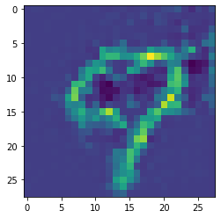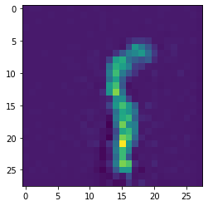

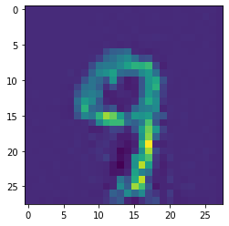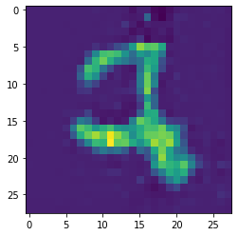

5) GAN will still be able to train both models as FC layers can be used to approximate any features, however it will take a longer time to train as the approximation cannot pick up the features as easily as the Transposed Conv2d layers, thus a longer convergence time is required.